Crisis Response and Homelessness Prevention Services

2019 - 2020
Proposed Contract Opportunities

February 2019
Contents

- Introduction
  - Purpose
  - Consultation and engagement
  - What’s in scope?
  - How to respond

- Priorities and drivers for change
  - Moving from a crisis model to a prevention model
  - Becoming housing led: reshaping accommodation and support which promotes sustainable independence
  - Better meeting the needs of the multiply excluded
  - Continuing to develop our ‘adaptive’ management approaches
  - Housing as a Human Right

- Summary of proposed contract opportunities
  - Contracts to be presented to the market
  - Timescales for procurement and contract duration
  - Finance

4. Determining the contract structure and lotting
4.1 Consolidation of service delivery models within the ‘service systems’
4.2 Opportunities to build in Social Value
4.3 Contract geography
4.4 Mixed models of delivery and the role of the Council’s Managing Agent in the Crisis Response and Homelessness Prevention marketplace

- Proposed delivery requirements
  - Essential delivery requirements for all contracts

- Commitment to Social Value

- Local need

- How to respond and next steps

Appendices:
Appendix A: Summary of current contracts
Appendix B: Summary of current service utilisation
Appendix C: Maps of current service provision
Appendix D: Geographical boundaries for contract ‘lots’ for the provision of the Crisis Prevention Hub
Appendix E: Service models: Key delivery requirements

- INTRODUCTION

  - Purpose

Newcastle City Council is seeking to put into place new contracts for the delivery of Crisis Response and Homelessness Prevention services.

This document outlines the proposed contract opportunities that will be offered to the market in 2019 and is the final stage of our consultation with stakeholders prior to commencing the competitive procurement process to put new contracts in place. It has been produced in the context of a number of stakeholder engagement and co-design sessions held in 2018, including engagement with individuals to share their lived experience of homelessness services in Newcastle and their thoughts on how they might be configured.

In producing this document, we aim to create a more transparent and cooperative approach to how these contract opportunities should be designed, prior to making a final decision on the contract structure and the scope of the service models. This document is intended to help a range of stakeholders identify the role they can play in the intended overall system to prevent homelessness in Newcastle, and to help develop their business plans. We hope that this document will also enable provider partners to respond to the identified contract opportunities, as well as bring forward new delivery models and ways of working.

1.2 Consultation and engagement

We held 16 stakeholder engagement and co-design sessions between July 2018 and January 2019. Overall around 170 service representatives, professionals, and those with lived experience of services have participated and provided feedback as part of this process.

The feedback from these engagement and co-design session have helped to inform the proposals in this document. A full summary of feedback from the engagement activities conducted to date, along with presentations or materials delivered at the sessions, can be found here.

Some of the key themes from the feedback include:
- The current system works well for many people, however, different responses are required to better meet the needs of people who are multiply excluded and at risk of repeat homelessness linked to more complex or multiple needs.
- Integration of care coordination, health pathways, and specialist support were key to meeting the needs of people with complex and/or multiple needs.
- Data payments were generally supported as a mechanism to improve the quality of Gateway information, but that sufficient time should be afforded before implementing payments by results for data completion to allow providers to carry out data cleansing and to understand the issues in their data, as well as the administrative requirements associated with data payments. Consideration of a mechanism to enable data transfer into Gateway would be welcomed, to reduce double entry, data errors or impact of administration requirements detracting from front line resources.
- Organisations and individuals would like the opportunity for improved flexibility within the support offered to enable more tailored support to individual needs.
- A move towards improved information sharing within multi-disciplinary settings is welcomed but requires commitment from relevant statutory and non-statutory organisations involved in the client group.
- Individuals with lived experience of services specifically highlighted that hostels needed to be smaller with less people living on one site.
- Throughout the engagement sessions there was a consistent view that more specialist support is required within accommodation settings for individuals with very chaotic lives and/or dual diagnosis of mental health and or substance misuse, whether this is through up-skilling current workforce or bringing in specialist staff or professionals.

1.3 What’s in scope?

In 2014, Newcastle City Council commissioned Crisis Response and Homelessness Prevention services to enable accommodation and support to be provided in the context of four ‘service systems’:

- Support for single homeless people, couples and homeless families including those with multiple needs (such as, but not limited to, those with problematic drug and alcohol use, offending behaviour, mental health problems, learning disabilities, refugees, older homeless people, veterans)
- Support for young people aged 16-24 at risk, including those with chaotic lives, care leavers, teenage parents, and young LGBT people
- Support for people with mental health problems who need housing related support associated with their mental health needs
- Support for people who are multiply excluded

Through this commissioning activity, several partnerships were established to deliver Crisis Response and Homelessness Prevention services, and these ‘service systems’ continue to provide useful opportunities for collaboration. We have therefore continued to use these ‘service systems’ when considering the contract opportunities for 2019.

We have appended to this document some information on the Crisis Response and Homelessness Prevention services currently commissioned from third party providers. The information is intended to help existing and potential service providers to understand the current market mix and explore opportunities for collaboration.

The information includes:
- Appendix A: a list of the housing-related support services currently commissioned, along with their service capacity, and current contract values
- Appendix C: maps showing the locations of the accommodation-based services currently commissioned across the city

Information on the utilisation of existing services can be found in section 7: Local Need, which draws upon information already published in the Council’s quarterly Homelessness Prevention Briefings, and Appendix B which provides a summary of the current service utilisation of the current contracts.
1.4 How to respond

You can comment on the proposals in this document by emailing stacey.urwin@newcastle.gov.uk. Alternatively, you can feedback on these proposals online at Let’s Talk Newcastle.

Responses should be submitted no later than noon on Monday 18 March 2019.

See section 8 for more information.

- PRIORITIES AND DRIVERS FOR CHANGE

The contracts to be presented to the market are proposed in the context of our homelessness statutory duties and policy aims (see how we are responding to the Homelessness Reduction Act 2017 here), including the priorities detailed below.

These contracts also seek to help us respond to a number of key challenges, including:

- services and supply that can respond to dynamic demand
- having sufficient accessible accommodation empty to respond to crisis presentations
- being able to safely accommodate and support people who have unmet complex health needs (e.g. for those individuals who providers cannot accommodate due to risks, and those who refuse an offer of accommodation).

2.1 Moving from a crisis model to a prevention model

Building on our ambition to make the prevention of homelessness everyone’s business, and maximising our collective skills, knowledge, experience and resources to help residents establish and maintain the foundations for a stable LIFE:

- somewhere to live
- an income
- financial inclusion
- employment opportunities

This involves continuing to build on Active Inclusion Newcastle’s partnership approach and activities across:

Primary prevention – for those residents who may be at risk of homelessness in the future, but are not immediately threatened in the next 2 months
- Information, consultancy lines and resources
- Training – online and face-to-face
- Quarterly reviews and opportunities to jointly plan

Secondary prevention – for those residents who are threatened within the statutory definition of the Homelessness Reduction Act 2017
- Specialist advice
- Protocols, e.g. Hospital Discharge
- Tailored training
- Single points of contact for designated liaison, including joint case management
- Information sharing and case recording arrangements
- Co-located staff
- Proactive case finding – data sharing to identify and contact residents at risk

Crisis – for those residents who are ‘literally’ homeless (they do not have any accommodation they can reasonably occupy), for those in crisis we aim to provide humane multidisciplinary responses in good time in good quality environments

  - Becoming housing led: reshaping accommodation and support which promotes sustainable independence

We want to move from a hostel by default model, to a housing by default model, providing rapid rehousing into settled accommodation to help people move on from homelessness as quickly as possible. This includes:

- Flexible accommodation offers that respond to fluctuating and unpredictable levels of demand, ensuring that accommodation can always be offered to people in a crisis, this may also include a tailored response during periods of severe weather
- Housing First type offers which prioritise rapid access to a stable home, from which other support needs can be addressed through coordinated and multi-disciplinary intensive support. This will be aligned to the principles described by Homeless Link and will require a different approach from all partners in how accommodation and support is delivered
- Transformed accommodation offer to create smaller, psychologically informed environments for those people with the most complex needs
- Multi-disciplinary support to meet a wide range of health-related needs (including drugs and alcohol, mental health, physical health needs) using more trauma informed approaches and therapeutic interventions
- All residents having a rehousing plan for rapid move on into decent, affordable, suitable and sustainable accommodation, with appropriate community-based support to prevent repeat homelessness. Where an Inclusion Plan is also in place, the support and rehousing plan should be aligned with the actions set out in the Inclusion Plan.

2.3 Better meeting the needs of the multiply excluded

Street Zero brings together a range of partners across the city (public sector, charities, businesses, voluntary and community groups and churches) working towards a joint plan to end rough sleeping in the city by 2022. This involves working together to routinely understand the causes of rough sleeping and multiple exclusion and aligning resources to respond to these needs. This includes:

- Integrated street outreach to manage crisis and safety planning – housing, mental and physical health, addictions, offending.
- Designated care coordination for rough sleepers, operating within multidisciplinary arrangements
- Rapid rehousing
- PR campaign and single charitable giving point to fund initiatives and personalised budgets that enables residents to move away from a life on the streets and prevent people from returning to the streets

2.4 Continuing to develop our ‘adaptive’ management approaches

We will build on the foundations of the Active Inclusion Newcastle partnership approach by creating a culture of collaboration with commissioned service providers to support us in achieving our ambition to make the prevention of homelessness everyone’s business.

Outcome focussed service delivery models aligned to our statutory duties and policy aims must be more responsive and seek innovative ways of identifying risk and responding to crisis. By working together, strengthening our evidence base with robust data, we will better understand people’s experiences of homelessness, including their journeys into and out of the homelessness ‘system’, so that we may jointly develop appropriate and humane responses.

This approach will be built around a framework of standards, underpinned with ways of working that are based around:

- Shared accountability and leadership with an active role in Newcastle’s homelessness prevention system, challenging decisions that may lead to or increase the risk or threat of homelessness to ensure there is a positive outcome, working in collaboration with other partners within and outside of the homelessness system to achieve positive outcomes
- Real time problem solving using quantitative and qualitative evidence
- Learning together - systemic, iterative and adaptive - allowing space for incremental and active learning that is based on live cases
- Responding and adapting quicker through better understanding of what works and what doesn’t work and being more creative in considering options to offer the most appropriate solutions and responses, building in responses to spikes in demand
- Improving alignment to outcomes through deliberate processes of testing, evidence gathering and learning – increasing the chances of learning by increasing interaction
- Prototyping by trying, testing, learning, iterating, and adapting process, practice and policy

2.5 Housing as a Human Right

The proposed contracts are rooted in a human rights perspective that argues that all people have the right to housing that is safe, appropriate, affordable, suitable and sustainable, and that allowing people to fall into, and remain, homeless because of structural, systemic, and/or individual factors is not acceptable.

Service providers will actively work to mitigate against evictions and risk of evictions to ensure that the right to housing is maintained, engaging with other partners within the Crisis Response and Homelessness Prevention system, including the Housing Advice Centre. Where there is a breakdown in the placement, people will be treated fairly and consistently across the system and will be informed of their rights to appeal an eviction decision.

- SUMMARY OF PROPOSED CONTRACT OPPORTUNTIES

3.1 Contracts to be presented to the market

The Council proposes to publish 6 contract opportunities as follows:

Service system: Support for single homeless people, couples and homeless families including those with multiple needs (such as, but not limited to, those with problematic drug and alcohol use, offending behaviour, mental health problems, learning disabilities, refugees, older homeless people, veterans)

- Contract 1: For the provision of a Crisis Prevention Hub in the East of Newcastle upon Tyne

- Contract 2: For the provision of a Crisis Prevention Hub in the West of Newcastle upon Tyne

- Contract 3: For the provision of Citywide Supported Accommodation services - Lot 1

- Contract 4: For the provision of Citywide Supported Accommodation services - Lot 2

Support for young people aged 16-24 at risk, including those with chaotic lives, teenage parents, young LGBT people, and young people who may have been in care

- Contract 5: For the provision of supported accommodation and resettlement support for young people aged 16-24

Support for people with mental health problems who need housing related support associated with their mental health needs

- Contract 6: For the provision supported accommodation and floating support for people with mental health problems

Providers can choose to bid for as many, or as few, of these contracts as they choose (where they can meet the relevant requirements of the Selection Questionnaire).

However, the Council is proposing that
- Any one prime contractor can only be awarded one of Contracts 1 and 2
- Any one prime contractor can only be awarded one of Contracts 3 and 4

Further information about the requirements for delivering these contracts can be found in Section 5: Proposed Delivery Requirements.

3.2 Timescales for procurement and contract duration

The contracts will be awarded through a competitive procurement exercise conducted in accordance with the Social and Other Specific Services route above EU thresholds Procedure under the Public Contract Regulations 2015. It is anticipated the tenders will be published in late March 2019.

The contract term proposed is 4 years (2 years with 2 x 12-month options to extend) to commence on 1 October 2019.

We recognise that periodic procurements are only part of the picture in helping us to achieve our ambitions and transition our accommodation and support offer to better respond to local need. However, it is an opportunity to build on the good performance and partnerships achieved to date to improve how we respond to multiplicity of need (prototyping and piloting new approaches), and further generate social value through our commissioning activity.

We are however seeking organisations that will work with us during the life of the contracts to develop:

- Incremental and active learning – iterating and adapting to respond to need
- Dynamic problem solving – daily conversations and consensus and working with partners in more integrated ways to problem solve in real time
- Funding landscape – partnership working with other funders
- System health – investing in our relationships and interagency working, workforce development and the infrastructure required to build our evidence base

3.3 Finance

In putting in place new contracts from 1 October 2019, we propose to maintain overall funding at current levels for Crisis Response and Homelessness Prevention services.

The aggregated value (inclusive of the options to extend) will be £12,454,896. This equates to an annual value of £3,113,724.

The anticipated financial allocations for the 6 proposed contracts are as follows.

Please note that the final determination of contract values will be published in the tender documents as part of the procurement process.

Sector system | Contract | Anticipated Maximum Annual Value* (£)
Single Homeless | Contract 1: Crisis prevention hub - East  Contract 2: Crisis prevention hub - West | £500,916  £500,916
 | Contract 3: Supported accommodation citywide - Lot 1  Contract 4: Supported accommodation citywide – Lot 2 | £596,567  £596,567
Young people | Contract 5: Supported accommodation and resettlement | £430,243
Mental Health | Contract 6: Supported accommodation and floating support | £488,515

*The anticipated maximum annual value includes an element of Payment by Results (5% of annual value) in relation to the timely completion of data on Newcastle Gateway (“data payment”)

Important notices:

Void capacity: No additional monies will be forthcoming from the Council to maintain void capacity (emergency beds) to accommodate people who present as literally homeless. The successful Provider(s) will be required to ensure this requirement is met from within the financial contract envelope specified in the tender documentation.

Spot purchasing: The contracts will allow for the Council to spot purchase additional services up to a maximum of £40,000 per annum, in addition to the anticipated contract values set out above. This will allow for the provision of time limited interventions to secure accommodation for individuals with multiple and complex needs who would otherwise be excluded from accommodation services; this may be innovative solutions or the provision of additional or more intensive resources to be made available.

Data payments: We require accurate and timely information to prevent and sustainably relieve homelessness, as well as understand the causes of homelessness and the effectiveness of our responses.

There will continue to be a contractual obligation to use the Newcastle Gateway system (or any successive system) to accept referrals and manage placements into the services that will sit within the contracts described in 3.1 above. To enable us to develop a robust evidence base and to improve gaps in our data which impacts our ability to analyse the needs of people threatened with homelessness and evaluate the effectiveness of our responses, we propose to proceed with implementing a data payment element within these contracts.

Following feedback received through the engagement and co-design sessions, we have revised our proposals relating to the principles that will guide data payments as follows:

- Data payments will use a sliding scale and range of parameters that are applied to specific data payment targets. The data payment element will not exceed 5% of the overall contract value. Calculation of data payment targets achieved and related financial impact will take place on a quarterly basis in arrears:

- Year 1 will be a shadow period and there will be no financial impact for providers during the Year 1 shadow period. Data Payment ‘statements’ will identify opportunities to improve the data quality reported against the agreed metrics.

- In Year 2 (and any subsequent extension periods), the data payment element will have a financial impact. Where a successful provider does not achieve the data payment target, the data payment will be retained by the Local Authority.

The final details of the metrics and process of their application will be specified in the tender documentation (which may be preceded by a further co-design session).

- DETERMINING THE CONTRACT STRUCTURE AND LOTTING

4.1 Consolidation of service delivery models within the ‘service systems’

In putting in place new contract arrangements in 2019, we are seeking to further consolidate the current contracts within the defined ‘sector systems’ in order to provide seamless end to end responses for people and afford greater opportunities for innovation and flexibility so that providers can tailor responses to individual need, as well as prototype and pilot new approaches.

Consolidation within the ‘sector systems’ seeks to:
- provide flexibility so that new models of support can emerge and respond to individuals’ needs in more responsive and flexible ways
- provide platforms for integration to respond to multiplicity of need; working with other providers with specific expertise in an area that complements own service offering
- enable the sharing of expertise, skills and experience to help to build thriving networks of collaboration across the city
- ensure that separate contracts do not stand in the way of efforts to deliver support in an integrated way
- use and share the knowledge gained through individual case work to continually contribute to policy development and service delivery and contribute towards preventing homelessness occurring in the first place
We welcome collaborative bids from organisations working together in order to provide the following responses. In developing these proposals, consideration was given to other potential options for structuring the contract opportunities. We believe that the options presented below supports the policy aims and priorities described in section 2 of this document.

Contract 1 and Contract 2: Crisis Prevention Hubs for single homeless people and couples (over 18)

These contract opportunities bring together the following services which are currently commissioned under separate contract arrangements:
- Crisis and emergency accommodation and support - crisis and emergency accommodation and support that is direct or quick access in order to respond to crisis situations that homeless people are often faced with; meeting immediate housing needs that may have arisen due to an emergency or crisis situation, including imminent threat / risk or serious harm or injury;
- Housing First – a choice-based, housing led citywide offer for people will present with multiple and complex needs and are likely to have been entrenched in the homelessness system, including multiple episodes of rough sleeping and for whom traditional alternative accommodation options have not been successful;
- Floating Support for non YHN tenants – this includes: resettlement support that helps people move on to the most appropriate level of independence and ensure they have the skills and resilience to sustain it, and preventative outreach support targeted at people at risk homelessness to prevent them losing their accommodation.

In bringing these elements together, we are seeking transformation from a crisis only response model, to one that actively responds to ending homelessness and rough sleeping. Crisis Prevention Hubs must support the shift from ‘managing’ homelessness to finding solutions.

In commissioning a Crisis Prevention Hub model, we are seeking to provide better opportunities to develop and provide a range of person-centred responses that are attuned to and reflect the personal circumstances of people, particularly with regards to their journey out of homelessness. This includes providing those who have been homeless, or are threatened with homelessness, with the necessary resources and support to access and stabilise their housing, enhance integration and social inclusion, and ultimately reduce the risk of the recurrence of homelessness.

Specifically, the Hubs will need to be able to meet unpredictable demand and ensure there is sufficient flexibility in void levels to respond to demand.

These interventions are aimed at those who are at risk of or threatened with homelessness as well as those who are literally homeless, with the aims of preventing homelessness, and moving out of homelessness as quickly as possible.

In consolidating these offers, we are seeking to enhance opportunities for learning to prevent people becoming homeless in the first place, and better anticipate and respond to fluctuating levels of need.

Contract 3 and Contract 4: Supported accommodation citywide for single homeless people and couples (over 18)

Maintains existing contract and lotting structure of two citywide supported accommodation services.

Contract 5: Supported accommodation and resettlement for young people aged 16-24

Maintains existing contract structure.

Contract 6: Supported accommodation and floating support for people with mental health problems (over 18)

This contract opportunity brings together two separately commissioned contracts under a single service specification, which seeks to consolidate and streamline access to accommodation and support through a single pathway.

4.2 Opportunities to build in Social Value

Social Value was considered to identify ways in which this commissioning and contracting opportunity could be designed to maximise the potential for Social Value. Key themes can be found at Section 6: Social Value, which summarises how the Council has, or intends to, incorporate feedback from the engagement into the commissioning and procurement process.

The Social Value discussion led the Council to propose dividing the activity into 6 contracts. We are not currently proposing to further divide the identified delivery requirements into smaller Lots as we believe there is interest in developing collaborative partnership arrangements. The Council would welcome comments from stakeholders on this proposal.

4.3 Contract geography

As part of the engagement activity with stakeholders, we explored the benefits of maintaining a geographical approach in the delivery crisis accommodation. Based on stakeholders’ feedback, the Council is therefore proposing to organise the contract opportunity for the provision of Crisis Prevention Hubs by geography, which mirrors current practice for the Crisis Accommodation provision.

A map of the proposed geographical boundaries is provided at Appendix D and includes the new boundary lines resulting from the ward changes in 2018.

The objectives that we are seeking achieve in organising the Crisis Prevention Hubs in geographic ways are:

- Opportunities to reduce demands on community infrastructures which may arise from services being concentrated in specific areas
- Opportunities to respond to needs of communities at a local level
- Opportunities to involve communities in developing responses
- Clarity of organisations and support available to meet the needs of communities
- Opportunities for closer working between the VCS and statutory agencies within geographical areas

4.4 Mixed models of delivery and the role of the Council’s Managing Agent in the Crisis Response and Homelessness Prevention marketplace

Your Homes Newcastle (YHN) is the Council’s Arms Length Management Organisation (ALMO) responsible for managing council homes on behalf of the Council. YHN was set up in 2004 to manage council properties, to improve housing in order to meet the Government’s Decent Homes standard, and to provide a range of support services for Newcastle City Council.

YHN will continue to deliver a range of homelessness prevention and housing-related support services to YHN tenants through the Support & Progression team, operating within one or more of the ‘service systems’ described above, to include:
- Pathways Team helping people to move to independent living:
  - pre-tenancy support for people moving on from supported accommodation
  - specialist support around hospital discharges and for people with mental health problems
- Refugee move-on team
- Outreach support for current tenants delivered from YHN Housing Service Hubs
- Support for young single people and young families:
  - floating support into YHN properties
  - supported accommodation at Stepping Stones and in North Kenton
- Assessments of housing and support needs of 16 and 17 year olds under the Joint Protocol arrangements, carried out by YHN at the Housing Advice Centre

- PROPOSED DELIVERY REQUIREMENTS

Appendix E sets out some of the proposed key elements relating to the service delivery requirements for the proposed contracts. This has been informed by the engagement and co-design activity to date. It seeks to help stakeholders, including potential providers, to understand the nature of the requirements that will be expected. It is not intended as a full draft service specification but sets out some of the proposed key elements that may inform the final service specification, which will be published as part of the tender documentation.

5.1 Essential delivery requirements for all contracts

5.1.1 Outcomes-focused delivery
The overall outcomes we are seeking include:

Increasing the number of people:
- For whom we prevent homelessness and repeat episodes of homelessness;
- Who live in improved buildings that services are delivered from;
- That move from homelessness to long term sustained independence;
- Being involved in meaningful activities and entering employment;
- Who use homeless services and we engage with to seek their views;
- Making successful transitions from institutions.

Reducing the number of people:
- Accepted as homeless, by offering appropriate preventative options;
- Evicted from all forms of housing;
- Accessing statutory temporary accommodation;
- Placed in bed and breakfast (the Housing Advice Centre has not placed anyone in B&B since 2006).

We believe that having a greater focus on outcomes gives providers greater opportunities to be more flexible and adaptive in their delivery of support. We are seeking to stimulate more innovative ways of working to develop solutions to achieve the outcomes above for some of the city’s most vulnerable residents.

5.1.2 Knowledge, experience and track record
We expect the successful Provider(s) to have demonstrable knowledge, experience and a good track record of delivering services in one or more of the contract opportunities described in 3.1 above.

Service delivery will be predicated on a solid knowledge of existing support services for those at risk of or threatened with homelessness to enable effective signposting and making the best use of facilities and resources available to these individuals in the city (including Council services, voluntary and community services and other organisations and services delivering across the city).

5.1.3 Partnership working
The Council’s aim of making the prevention of homelessness everyone’s business, can only be achieved with a focussed and robust partnership approach that builds on
collaborative practice and integrated working at a local level.
Collaborative and outcome focussed working will be central to successfully supporting people, and in particular those with multiple and complex needs; developing an approach that builds on positive engagement, information sharing and shared support planning.

We expect the successful providers (and their sub-contractors where appropriate) to not only offer flexible solutions within their own contractual partnership to meet the needs of people requiring support, but to also establish and maintain relationships with statutory and non-statutory organisations, and wider community partners and stakeholders both within the homeless sector and beyond.

The successful provider (prime contractor) will be awarded overall responsibility for the contract, including the identification of a designated lead contract manager where there are consortia contracts awarded. The prime contractor will determine the process for securing the quality assurance of any delivery partners they subsequently subcontract, and the Council will also require these delivery partners to have submitted a satisfactory response to the Council’s Selection Questionnaire (SQ) before they can be accepted as partners to these contracts. If at any stage following the award of the contract delivery partners should change, the prime contractor will be responsible for ensuring that new partners have submitted a satisfactory SQ to the Council.

5.1.3 Involvement and engagement of those with lived experience
Through service delivery, opportunities and activities must be available that engage and interest people, providing approaches that allow vulnerable people to gain self-respect, confidence and a network of friends.

We know that isolation and alienation are severe obstacles to establishing and sustaining independent living. Therefore, services will be required to help people reintegrate with the community through activities which promote and encourage: engagement; education; employment; involvement of service users; wellbeing and health.

Through the provision of empowering services and activities, service users should be supported to access education and training which may lead to qualifications and or employment, as well as meaningful occupation which encourages people to express themselves and learn new skills.

Establishing and maintaining partnerships with (specialist and universal) external providers will be essential in creating sustainable services and activities.

5.1.5 Staff experience, qualifications and training
The proposed contracts described in 3.1 seek to shift from a traditional ‘housing related support’ model, to one that focusses on person-centred therapeutic interventions that support people to move from homelessness services to greater independence and reducing the risk of repeat episodes of homelessness.

Bidders should consider the role of a multi-disciplinary team approach to enable an integrated and coordinated response for people with complex needs (drugs, alcohol, mental health, offending) who will be accessing the services within the contracts described in 3.1. We expect staff will be experienced in motivational interviewing techniques and taking an outcome focussed approach that uses strength-based interventions to provide support, and that capitalises on the assets of the individual.

The relationship between support staff and the people they are engaging with and supporting to move away from homelessness is crucial. Continuity of Support/ Key Worker and the skills they have to sustain successful engagement plays an important role.

Main expectations will include (but will not be limited to):

- Working with people experiencing homelessness to address the reasons for homelessness including health and other inequalities;
- Assessing and managing risk in partnership with other agencies, where appropriate and sharing of risk information;
- Developing a support plan in partnership with the individual, and other agencies, which also aligns to their personal housing plan (Inclusion Plan) to achieve positive outcomes;
- Embracing asset-based practices which recognises and builds on people’s skills, strengths, aspirations and networks and enabling them to be active in improving their own, and others wellbeing and health, rather than passive recipients of others’ actions;
- Providing integrated and psychologically and trauma informed therapeutic interventions;
- Working with other statutory and non-statutory services to ensure the health and well-being of service users (including, but not limited to: general practices, drug and alcohol services, criminal justice agencies, social and health care services, mental health teams, housing services, community and voluntary sector services); and
- Being flexible to meet the variable and individual needs of people being supported, including responding to crisis situations.

Staff must be able to demonstrate knowledge and experience of:

- Supporting the needs of people who have been homeless and relating to people who may have low levels of trust;
- Facilitating assessment of need and developing support plans in partnership with service users;
- Motivational interviewing techniques to strengthen service users’ own motivation and commitment to achieving goals;
- Successfully liaising with a variety of agencies;
- Substance misuse issues;
- Mental health issues;
- Anti-social behaviour;
- Safeguarding adult and Safeguarding children practices; and
- The skills required to work with people who are non-engaging.

We expect Support/ Key Workers to have the appropriate skills and training to enable them to successfully assess the needs of homeless people and develop appropriate support plans and interventions required to achieve agreed outcomes.

We expect all staff employed by the successful Provider to have completed the following training as a minimum standard:

- Safeguarding adults;
- Child protection awareness;
- Mental health awareness;
- Mental Capacity Act 2005;
- Health and safety awareness;
- Drug and alcohol awareness, including compliance with the Council’s Drug Management Protocol;
- Benefits and debt awareness;
- Housing and homelessness;
- Complaints handling;
- Data Protection Legislation, including the General Data Protection Regulations (GDPR) and the Data Protection Act 2018.

Staff should also be aware of, and be competent in, meeting the specific needs of a culturally diverse client group.

- COMMITMENT TO SOCIAL VALUE

The Council has made a Social Value Commitment which sets out four principles of Social Value; these principles are what Social Value means in Newcastle.

Organisations are required to explore how the requirements could best be designed to maximise social value, deliver better outcomes and to improve outcomes in the most efficient, effective, equitable and sustainable way and in the best interests of the City’s residents; including improved employment opportunities, creating skills and training opportunities (for example, apprenticeships or on the job training), improving access to community facilities, providing additional opportunities for individuals or groups facing greater social or economic barriers, encouraging ethical and fair trade purchasing. Providers should also explore opportunity to include members of the local community to participate in training delivered to staff; this would not only build relationships with groups and/ or residents but would also equip them with skills to identify and engage with hard to reach groups.

Through the Social Value engagement sessions in November we identified the following opportunities that could be incorporated or considered within this tender:

Social Value priorities | Opportunities identified | How these could be incorporated
Think, buy, support Newcastle | Construct contract lots that support local business opportunities.  Employment opportunities through work, apprenticeships, volunteering or training with an emphasis on targeting NEET population. | - Commissioning model  - ITT documents  - Performance measures/KPIS
Community focused | Signposting community opportunities to the market. | - ITT documents  - Contract management
Ethical leadership | Ethical standards in recruitment, employment and conditions.  Identification of workforce skills and opportunities for up-skilling into specialist roles. | - ITT documents, including a Supplier Questionnaire (SQ)  - Performance measures/KPIs
Green and sustainable | Capital investment in buildings/properties to improve energy efficiency, carbon impact etc | - ITT documents  - Contract management  - Performance measures/KPIs

- LOCAL NEED

  - Segmentation analysis

To enable us to better understand the needs of the homeless population in Newcastle we completed analysis on a segmented basis, based on service usage, where we can better understand the different patterns of service usage and the needs and characteristics of individuals within each of the segments. This more nuanced understanding will support us in better understanding the underlying causes of homelessness and the effectiveness of our commissioned responses.

The segmentation analysis can be found here

  - Service Utilisation

On a quarterly basis, the Council’s Active Inclusion Unit provides detailed information on homelessness prevention activity in Newcastle, which includes quantitative and qualitative data on utilisation of the current Crisis Response services. Briefings from previous years and the 2017/18 quarterly briefings to date can be found here.

Service utilisation for the current contracts in 2016/17 and 2017/18 is set out in Appendix B

8 HOW TO RESPOND AND NEXT STEPS

We would like to hear your views on our proposals. You can comment in writing by emailing stacey.urwin@newcastle.gov.uk. Alternatively, you can feedback on these proposals online at Let’s Talk Newcastle.

Responses should be submitted no later than noon on Monday 18 March 2019.

We will consider the feedback received prior to determining the final contract structure and tendering for services in late March 2019. Current commitments will be maintained up to 30 September 2019 to allow sufficient time for the new arrangements to commence on 1 October 2019.

All tender documentation will be published on the NEPO Electronic Tendering Portal at www.nepoportal.org

To be considered for the opportunities, please register your details free of charge on the above NEPO Electronic Tendering Portal. Once registered you will be able to express an interest and download the tender documentation. You can register your details on the NEPO Electronic Tendering Portal by entering the ‘Suppliers Area’ and following the registration instructions.

If you experience a problem registering, please contact: NEPO Support Team, By Tel: 0191 261 3940 or By Email: info@nepoportal.org

Appendix A: Summary of current contracts

Contract | Lead Provider | Commissioned units | Contract Value
Crisis accommodation – East | Home Group | 67 | £320,786
Crisis accommodation – West | Changing Lives | 63 | £320,786
City wide supported accommodation and resettlement support | Changing Lives | 195 | £596,567
City wide supported accommodation and resettlement support | Home Group | 208 | £596,567
City wide floating support for homeless people | Changing Lives | 140 | £183,986
City wide support for people who are multiply excluded (Outreach* and Housing First) | Changing Lives | 120 | £374,186
Accommodation and support for young people | Home Group | 100 | £416,943
City wide supported accommodation | Mental Health Concern | 68 | £270,428
City wide floating support | Karbon Homes | 88 | £218,087
*The street outreach element of this contract is not included within the contract opportunities proposed in section 3.1

Appendix A excludes additional funding brought to bear for the provision of spot purchase arrangements and for maintaining void capacity for emergency beds.

Appendix B: Utilisation of Current Contracts

Crisis accommodation and support (aggregated data for East and West) |  | 2016-17 | 2017-18
Number who have moved on in a planned way | To independence | 201 | 158
 | To another supported housing placement | 41 | 43
 | To family / friends | 157 | 88
 | Other | 0 | 0
Number of unplanned moves | To independence | 0 | 4
 | To another supported housing placement | 65 | 6
 | Evicted | 120 | 118
 | Other (including deceased and abandonments) | 100 | 118
Number of clients evicted from services | Alcohol abuse | 1 | 0
 | Disruptive behaviour | 16 | 23
 | Drug abuse | 2 | 9
 | Rent arrears | 12 | 13
 | Theft | 1 | 2
 | Violence to residents | 14 | 41
 | Violence to staff | 5 | 13
Referrals received (multiple referrals, not individuals) |  | 1442 | 1466
Refused |  | 294 | 443
Admits into services |  | 476 | 401
Clients resident over 9 months on final day of quarter |  | 8 | 13

Citywide supported accommodation and resettlement support (aggregated data for current contracts) |  | 2016-17 | 2017-18
Number who have moved on in a planned way | To independence | 121 | 88
 | To another supported housing placement | 121 | 66
 | To family / friends | 0 | 0
 | Other | 0 | 49
Number of unplanned moves | To independence | 0 | 18
 | To another supported housing placement | 0 | 3
 | Evicted | 43 | 51
 | Other (including deceased and abandonments) | 43 | 116
Number of clients evicted from services | Alcohol abuse | 0 | 1
 | Disruptive behaviour | 4 | 18
 | Drug abuse | 0 | 5
 | Rent arrears | 9 | 10
 | Theft | 1 | 1
 | Violence to residents | 2 | 4
 | Violence to staff | 1 | 5
Referrals received (multiple referrals, not individuals) |  | 3327 | 3148
Refused |  | 1406 | 1557
Admits into services |  | 437 | 401
Clients resident over 2 years on final day of quarter |  | 76 | 66

Citywide floating support for homeless people | 2016-17 | 2017-18
Number moved on to greater independence | 24 | 38
Number moved on but are no longer living independently | 10 | 32
Referrals received (multiple referrals, not individuals) | 128 | 277
Refused | 21 | 53
Admits into services | 42 | 91
Clients resident over 2 years on final day of quarter | 23 | 29

Supported accommodation and support for young people |  | 2016-17 | 2017-18
Number who have moved on in a planned way | To independence | 13 | 25
 | To another supported housing placement | 35 | 18
 | To family / friends | 0 | 22
 | Other | 0 | 6
Number of unplanned moves | To independence | 0 | 0
 | To another supported housing placement | 28 | 5
 | Evicted | 24 | 8
 | Other (including deceased and abandonments) | 23 | 33
Number of clients evicted from services | Alcohol abuse | 0 | 0
 | Disruptive behaviour | 8 | 2
 | Drug abuse | 0 | 0
 | Rent arrears | 3 | 0
 | Theft | 0 | 0
 | Violence to residents | 6 | 0
 | Violence to staff | 4 | 2
Referrals received (multiple referrals, not individuals) |  | 473 | 390
Refused |  | 36 | 93
Admits into services |  | 146 | 116
Clients resident over 2 years on final day of quarter |  | 4 | 8

Support for people with mental health problems

Citywide supported accommodation |  | 2016-17 | 2017-18
Number moved on to greater independence |  | 16 | 10
Number moved on but are no longer living independently |  | 11 | 11
Number of clients evicted from services | Alcohol abuse | 0 | 0
 | Disruptive behaviour | 0 | 2
 | Drug abuse | 0 | 0
 | Rent arrears | 0 | 0
 | Theft | 0 | 0
 | Violence to residents | 0 | 0
 | Violence to staff | 0 | 0
Referrals received (multiple referrals, not individuals) |  | 388 | 285
Refused |  | 62 | 77
Admits into services |  | 15 | 21
Clients resident over 5 years on final day of quarter |  | 26 | 24
City wide floating support |  | 2016-17 | 2017-18
Number moved on to greater independence |  | 41 | 11
Number moved on but are no longer living independently |  | 15 | 15
Referrals received (multiple referrals, not individuals) |  | 69 | 83
Refused |  | 5 | 13
Admits into services |  | 44 | 36
Clients resident over 5 years on final day of quarter |  | 16 | 15

Appendix C: Maps of current service provision

Crisis Accommodation and Support

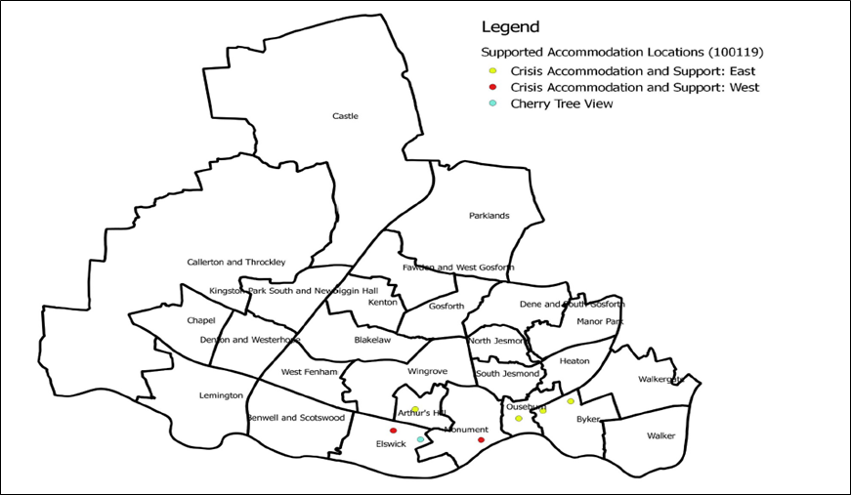

Citywide Supported Accommodation and Resettlement Support

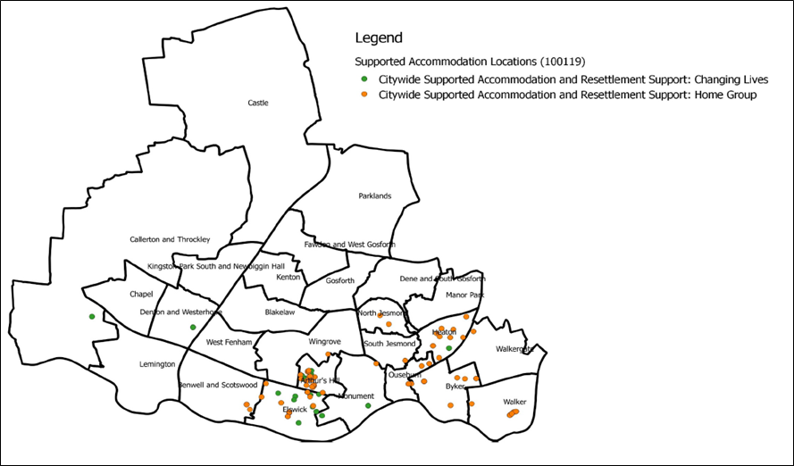

Accommodation and Support for Young People

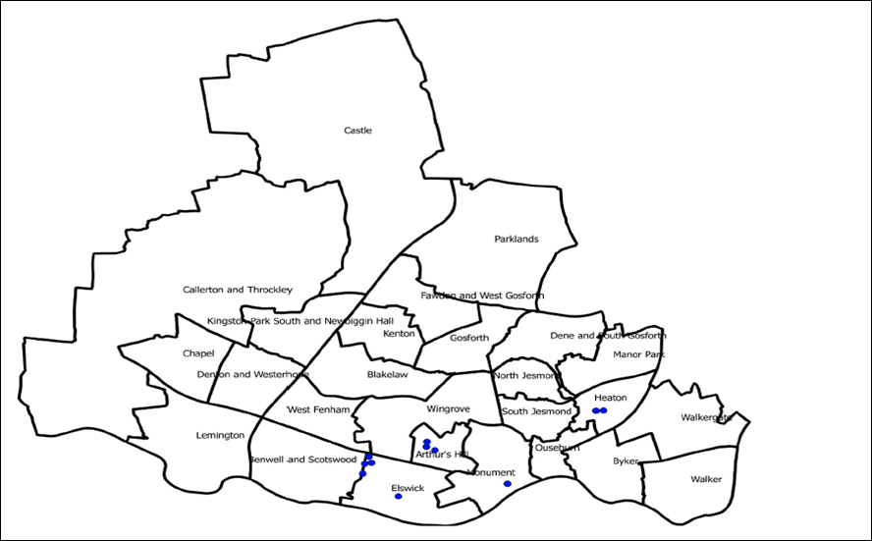

Supported Accommodation for People with Mental Health Problems

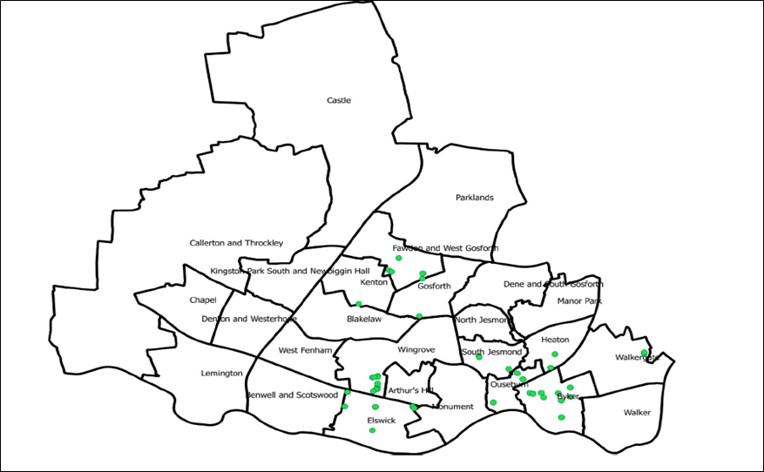

Appendix D: Geographical boundaries for Contract 1 and Contract 2 for the provision of Crisis Prevention Hubs

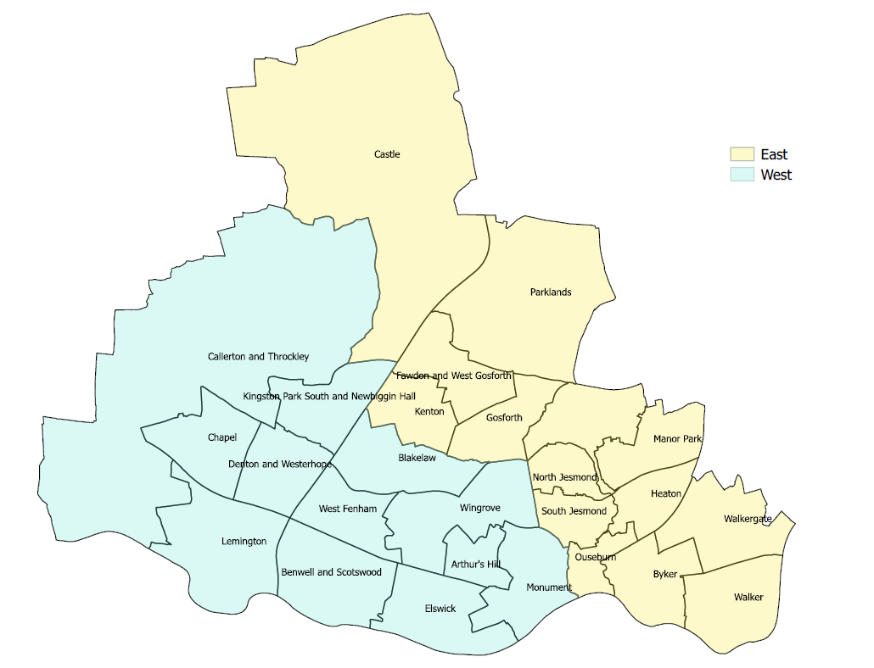

Appendix E: Service Models – Key delivery requirements

Crisis Prevention Hubs (East and West)

Service requirements | Type of support | Type of needs | Admit criteria, length of stay, unit capacity
Two geographical locations each with a Crisis Prevention Hub providing the following elements:  - Crisis Accommodation  - Emergency bed (void capacity)  - Housing First  - Preventative outreach  An assessment of need that ensures the most appropriate accommodation offer is made.  Rapid re-housing options to be a consideration.  The accommodation provision must be able to respond to fluctuating and unpredictable levels of demand, ensuring that accommodation can always be offered to people in a crisis.  Crisis Accommodation  Provision of humane multidisciplinary responses in smaller, psychologically informed environments in good quality accommodation in community-based settings, that deliver person centred support.  Responsiveness  Accommodation must be staffed 24/7 with appropriate staffing levels that enable risk to be managed safely.  The accommodation offer also needs to be able to respond to people for whom communal living is not appropriate or conducive to success.  Accurate and current risk and need information is shared between agencies.  Emergency Bed Provision  Provision of emergency or ‘crisis’ beds within this contract (rather than in addition to) that offer a rapid and brief response to people who are literally homeless.  Beds to be kept void unless referred into by the Housing Advice Centre.  Move-on Planning  A planned and structured move on process that capitalises on the assets, capacity, and resilience of the individual so that they can access more independent accommodation, which may be offered through the citywide supported accommodation contracts, or an independent tenancy.  Information Sharing  Consent to share risk and needs information between agencies, and that it should be accurate and current.  Safeguarding  Local safeguarding (adults and children) procedures to be adhered to. | Support Delivered in Crisis Accommodation  Support to be person centred, not prescriptive and therefore flexible to meet an individual’s changing needs and their potential fluctuating levels of engagement.  Support to be focussed on the prevention of homelessness and mitigate against repeat cycles of homelessness.  Outcome focussed ways of working that use strength-based approaches to provide support, and that capitalises on the assets of the individual.  Define and agree support plan actions that are aligned to the Inclusion Plan and are outcome focussed.  Provision of trauma informed care that takes an integrated approach.  Develop and coordinate multi-agency responses, through potential co-location opportunities to facilitate access to and engagement with support provision to reduce crisis for those with complex needs (drugs, alcohol, mental health, offending).  Multi-agency and holistic support to create and promote sustainable independence.  A structured move on process that considers and facilitates access to a range of suitable and sustainable accommodation options.  Resettlement Support  To be delivered on a citywide basis (as required) to people moving on from that Crisis Prevention Hub, and be able to flexibly respond to need and may be offered on a longer-term basis to enable independence to be maintained and to mitigate against repeat presentation to homelessness services. | Support Needs for all Elements of the Crisis Prevention Hub  Support for single homeless people and couples including those with multiple needs (such as, but not limited to, those with problematic drug and alcohol use, offending behaviour, mental health problems, learning disabilities, refugees, older homeless people, veterans) | Referrals and Admit  Referrals into the Crisis Prevention Hub via the Newcastle Gateway or directly from the Housing Advice Centre.  Admit Criteria  The Crisis Prevention Hub will support people aged 18+ years of age.  For people who are literally homeless or who are threatened with homelessness within the next 7 days.  Duration of Support  Being less prescriptive about the period to be spent in crisis accommodation.  For some, crisis accommodation should be a short-term stepping stone to greater independence, for others where they have ongoing needs, more intensive support may be required for a longer time. In both cases, support planning should be more focussed on developing the capacity and resilience of the individual to prepare them to move-on to greater independence.  Expectation that stays in the ‘emergency beds’ continue to be at 5 days, before being moved to more suitable accommodation.  Unit Capacity  Smaller units of accommodation; the ‘ideal’ size is still to be defined, and some of this will be driven by asset availability (currently single self-contained units of dispersed accommodation to a single site of 52 units).
Housing First  Fidelity to the seven principles of Housing First  - Access to housing is as quickly as possible and provision is based on suitability.  - Long term offers of support, which is flexible and meets individual need.  - Support and housing are separate.  - Choice and control over housing, and engagement with other services  - Small caseloads to enable proactive, persistent approach.  - Based on people’s goals, strengths and aspirations.  - Support through a harm reduction approach (substances) and to improve their physical and mental health, and their wellbeing.  Information Sharing  Consent to share risk and needs information between agencies, and that it should be accurate and current.  Safeguarding  Local safeguarding (adults and children) procedures to be adhered to. | Support Delivered in Housing First Accommodation  Support to be person centred, not prescriptive and therefore flexible to meet an individual’s changing needs and their potential fluctuating levels of engagement.  Intensive support to be focussed on the prevention of homelessness and mitigate against repeat cycles of homelessness.  Provision of trauma informed care that takes an integrated approach.  Develop and coordinate multi-disciplinary responses, through potential co-location opportunities to facilitate access to and engagement with support provision to reduce crisis for those with complex needs (drugs, alcohol, mental health, offending).  Multi-agency and holistic support to create and promote sustainable independence.  Specialist workforce with demonstrable skills and experience of successfully engaging with and supporting people with multiple and complex needs (must be a different offer from generic homelessness ‘Support Worker’ role) | Support Needs Specific to Housing First  People will present with multiple and complex needs (including but limited to those with problematic drug and alcohol use, offending behaviour, mental health problems, learning disabilities, refugees, older homeless people, veterans) and are likely to have been entrenched in the homelessness system, including multiple episodes of rough sleeping and for whom traditional alternative accommodation options have not been successful. | Referrals and Admit  Referrals into Housing First will be through a closed route with admit and suitability criteria to be defined.  Admit Criteria  Housing First will support people aged 18+ years of age.  Unit Capacity  Single units of self-contained accommodation that is dispersed citywide.  Due to the intensive nature of the support provided through Housing First, this element of the service is likely to be for no more than 20 people at any one time.  Duration of Support  This will be determined by the effectiveness of the support and interventions delivered, but intensity of support should reduce in line with increased independence.
Preventative Outreach Support  A primary and secondary prevention approach for people threatened with homelessness, offering targeted responses to individuals on a case by case basis.  To be delivered on a geographical basis to those at risk of, or threatened with homelessness within the geographical boundary of the Crisis Prevention Hub.  Information Sharing  Consent to share risk and needs information between agencies, and that it should be accurate and current.  Safeguarding  Local safeguarding (adults and children) procedures to be adhered to. | Preventative Outreach Support  Delivered to people who are at risk of, or threatened with homelessness in their current accommodation.  Support to be focussed on the prevention of homelessness and mitigate against repeat cycles of homelessness, which may include, but should not be limited to:  - Support to liaise with landlord to prevent risk of eviction;  - Maximising income by assessing entitlement to welfare benefits and support with the benefit claim process;  - Access to discretionary funding;  - Budgeting support, and if required support to address debt issues;  - Support to access employment, training and volunteering opportunities;  - Support to access treatment and recovery services in relation to substance misuse (psychosocial and pharmacological interventions);  - Support to access mental health services.  Support to be person centred, not prescriptive and therefore flexible to meet an individual’s changing needs and their potential fluctuating levels of engagement.  Outcome focussed ways of working that use strength-based approaches to provide support, and that capitalises on the assets of the individual.  Define and agree support plan actions that are aligned to the Inclusion Plan (if in place) and are outcome focussed.  Multi-agency and holistic support to create and promote sustainable independence.  Consider alternative accommodation options to ensure affordability, suitability and sustainable, with specialist support for people who are either employed or are experiencing a change of circumstance that may impact them financially. | Support Needs  Support for single homeless people and couples including those with multiple needs (such as, but not limited to, those with problematic drug and alcohol use, offending behaviour, mental health problems, learning disabilities, refugees, older homeless people, veterans) | Referrals and Admit  Referrals into the Crisis Prevention Hub are via the Newcastle Gateway or directly from the Housing Advice Centre.  Admit Criteria  The service will support people aged 18+ years of age.  This element of the Crisis Prevention Hub is for people who are not Your Homes Newcastle tenants, and who’s postcode is within the geographical boundaries of that Crisis Prevention Hub.  For people who are threatened with homelessness within the next 7 days, and for whom an intervention would prevent admit into the Crisis Prevention Hub.  For people who are not threatened with homelessness within the next 7 days, and for whom a more structured and longer-term support plan is required to mitigate against the risk of homelessness.  Duration of Support  To mitigate the need for a crisis intervention, including admit into the Crisis Prevention Hub, support will be offered on a preventative basis, and should flexibly respond to the needs of the individual, supporting them to develop their capacity and resilience to enable them to maintain independent living in the community.

Citywide Supported Accommodation

Service requirements | Type of support | Type of needs | Admit criteria, length of stay, unit capacity
Supported Accommodation  Provision of humane multidisciplinary responses in smaller, psychologically informed environments in good quality accommodation in community-based settings, that deliver person centred support.  The accommodation offer should include a range of options including accommodation with communal facilities, but also self-contained dispersed properties, or self-contained units in Houses of Multiple Occupancy.  An assessment of need that ensures the most appropriate accommodation offer is made.  Responsiveness  Accommodation must have an emergency response 24/7 with appropriate staffing levels that enable risk to be managed safely within the environment.  Move-on Planning  A structured assessment of move-on readiness is regularly and consistently applied to manage perceptions and expectations of independent living.  A planned and structured move on process that capitalises on the assets, capacity, and resilience of the individual to enable them to sustain living independently.  Information Sharing  Consent to share risk and needs information between agencies, and that it should be accurate and current.  Safeguarding  Local safeguarding (adults and children) procedures to be adhered to. | Support Delivered in Supported Accommodation  Support to be person centred, not prescriptive and therefore flexible to meet an individual’s changing needs and their potential fluctuating levels of engagement.  Support to be focussed on the prevention of homelessness and mitigate against repeat cycles of homelessness.  Outcome focussed ways of working that use strength-based approaches to provide support, and that capitalises on the assets of the individual.  Define and agree support plan actions that are aligned to the Inclusion Plan and are outcome focussed.  Supported to register on Tyne and Wear Homes (TAWH), and to follow the process through the provision of appropriate documentation, references, debt payment plans etc.  A structured move on process that considers and facilitates access to a range of suitable and sustainable accommodation options.  Resettlement support  To flexibly respond to need and may be offered on a longer-term basis to enable independence to be maintained and to mitigate against repeat presentation to homelessness services. | Support Needs  Support for single homeless people and couples including those with multiple needs (such as, but not limited to, those with problematic drug and alcohol use, offending behaviour, mental health problems, learning disabilities, refugees, older homeless people, veterans) | Referrals and Admit  Referrals into services are via the Newcastle Gateway or directly from Housing Advice Centre to respond to statutory duty.  Supported accommodation should not be solely used as the move-on option from crisis accommodation.  Referrals following assessment in the Crisis Prevention Hubs, may be for people who do not need intensive crisis accommodation and can be referred to supported accommodation instead.  For people who are literally homeless or who are threatened with homelessness within the next 7 days, and for which a responsive interview process is required.  For people who are not literally homeless or who are threatened with homelessness within the next 7 days. i.e., within 8-56 days.  Duration of Support  Being less prescriptive about the period to be spent in supported accommodation; planning should be more focussed on developing the capacity and resilience of the individual to ensure they have the necessary skills that will enable them to live independently.  For others where they have ongoing needs, more intensive support may be required for a longer time. In both cases, support planning should be focussed on developing the capacity and resilience of the individual to prepare them to move-on to independence.

Young People - Supported Accommodation and Resettlement

Service requirements | Type of support | Type of needs | Admit criteria, length of stay, unit capacity
Supported Accommodation  Provision of humane multidisciplinary responses in smaller, psychologically informed environments for young people; offering good quality accommodation in community-based settings, and person-centred support.  The accommodation offer also needs to be able to respond to people for whom communal living is not appropriate or conducive to enabling them to achieve their goals.  The accommodation provision must be able to respond to fluctuating and unpredictable levels of demand, ensuring that accommodation can always be offered to people in a crisis.  Emergency Beds  Provision of emergency or ‘crisis’ beds within this contract (rather than in addition to) with an expectation that they are kept void unless referred into by the Housing Advice Centre.  Responsiveness  Accommodation must have a 24/7 response with appropriate staffing levels that enable risk to be managed safely.  Information Sharing  Consent to share risk and needs information between agencies, and that it should be accurate and current.  Safeguarding  Local safeguarding (adults and children) procedures to be adhered to.  Move-on Planning  A planned and structured move on process that is focussed on developing the skills required to enable young people live independently and to access suitable and sustainable accommodation. | Support Delivered in Supported Accommodation  Support to be person centred, not prescriptive and therefore flexible to meet an individual’s changing needs and their potential fluctuating levels of engagement.  Support to be focussed on the prevention of homelessness and mitigate against repeat cycles of homelessness.  Outcome focussed ways of working that use strength-based approaches to provide support that capitalises on the assets of the individual.  Define and agree support plan actions that are aligned to the Inclusion Plan and are outcome focussed.  Opportunities for co-location of practitioners to facilitate the provision of integrated, and psychologically and trauma informed interventions to reduce crisis for those with complex needs (drugs, alcohol, mental health, offending).  Develop and coordinate multi-agency responses that create and promote sustainable independence.  Resettlement Support  Must be delivered flexibly to respond to need and may be offered, where required, on a longer-term basis to enable independence to be maintained and to mitigate against repeat presentation to homelessness services. | Support Needs  The range of needs that young people may present with include but are not limited to:  - care leavers;  - teenage parents;  - risk of violence and/or abuse;  - risk of eviction or exclusion for anti-social behaviour;  - previous homelessness or rough sleeping;  - offending or offending behaviour;  - self-defined as lesbian, gay, bi-sexual, transgender or queer (LGBTQ);  - diagnosed or undiagnosed mental health problems;  - learning difficulties and or disabilities;  - drug and alcohol problems;  - being refugees/asylum seekers; and  - being a young carer. | Referrals and Admit  Referrals into services are via the Newcastle Gateway or directly from Housing Advice Centre.  Admit Criteria  The service will support young people aged 16-24 years of age.  Duration of Support  In being less prescriptive about the period to be spent in supported accommodation; planning should be more focussed on developing the capacity and resilience of the young person to prepare them to move-on to independence.  Expectation that stays in the ‘emergency beds’ continue to be at 5 days, before being moved to more suitable accommodation.  Unit Capacity  Smaller units of accommodation; the ‘ideal’ size is still to be defined, and some of this will be driven by asset availability (for info, current provision ranges from single self-contained units of dispersed accommodation to a single site of 52 units).

Mental Health - Supported accommodation and floating support

Service requirements | Type of support | Type of needs | Admit criteria, length of stay, unit capacity
Supported Accommodation  High quality accommodation and support in community-based settings, that enables people with a mental health problem to gain and retain the skills necessary to live as independently as possible by promoting these skills and promoting social inclusion.  Accommodation Offer  The accommodation offer needs to be able to respond to people for whom communal living is not appropriate or conducive to success.  Provision of a range of accommodation offers that are driven by support requirements:  - Short or long-term accommodation and support to remain living in the community  - Short term accommodation and support to help them gain the skills for independent living.  - Short term accommodation and support to help them resettle into the community  Responsiveness  Accommodation must have a 24/7 response with appropriate staffing levels that enable risk to be managed safely.  Information Sharing  Consent to share risk and needs information between agencies, and that it should be accurate and current.  Safeguarding  Local safeguarding (adults and children) procedures to be adhered to. | Supported Delivered in Supported Accommodation  Specialist support to be person centred, not prescriptive and therefore flexible to meet an individual’s changing needs and their potential fluctuating levels of engagement.  Support to be focussed on maintaining or improving an individual’s mental health, whilst ensuring that their homelessness is prevented.  Outcome focussed ways of working that use strength-based approaches to provide support that capitalises on the assets of the individual.  Define and agree support plan actions that may be aligned to the Inclusion Plan and are outcome focussed.  Opportunities for co-location of practitioners to facilitate the provision of integrated, and psychologically and trauma informed interventions to reduce crisis for those with complex needs (drugs, alcohol, mental health, offending).  Develop and coordinate multi-agency responses that create and promote sustainable independence.  Resettlement Support  Must be delivered flexibly to respond to need and may be provided on a longer-term basis to maintain the greater level of independence and prevent crisis. | Support Needs  Respond to a wide range of circumstances in which people with mental health problems who require support accommodation, including but not limited to:  - People who are leaving hospital, crisis beds, mental health residential care or prison  - People who are struggling to manage their tenancy and are at risk of becoming homeless or a hospital admission or into mental health residential care  - People who are living in temporary accommodation | Referrals and Admit  Referrals into services are via the Newcastle Gateway or directly from the Housing Advice Centre.  Admit Criteria  The service will support people aged 18+ years of age.  Duration of Support  In being less prescriptive about the period to be spent in supported accommodation; planning should be more focussed on developing the capacity and resilience of the person to prepare them to move-on to greater independence.  For people who have ongoing needs, more intensive support may be required for a longer time. In all cases, support planning should be more focussed on developing the capacity and resilience of the individual, this may include support to prepare them to move-on to greater independence.  Longer-term support to maintain their tenancy to help them live independently in the community.  Unit Capacity  Smaller units of accommodation provided on a dispersed on a citywide basis; some sites will offer shared accommodation, some will be self-contained.
Floating Support  Visiting floating support that is delivered on a citywide basis and enables people to gain and retain the skills necessary to continue to live as independently as possible by promoting those skills and social inclusion:  - low level support; whereby only minimal contact is required to monitor the service user and ensure they do not regress and lose the ability to cope and manage their accommodation;  - intermediate support whereby a crisis has been addressed and the service user has become established and their needs remain substantial but have stabilised; and  - a highly intensive level of support; needing a short-term but intensive approach.  Information Sharing  Consent to share risk and needs information between agencies, and that it should be accurate and current.  Safeguarding  Local safeguarding (adults and children) procedures to be adhered to. | Specialist support to be person centred, not prescriptive and therefore flexible to meet an individual’s changing needs and their potential fluctuating levels of engagement.  Support to be focussed on maintaining or improving an individual’s mental health, whilst ensuring that their homelessness is prevented.  Outcome focussed ways of working that use strength-based approaches to provide support that capitalises on the assets of the individual.  Define and agree support plan actions that may be aligned to the Inclusion Plan and are outcome focussed  Opportunities for co-location of practitioners to facilitate the provision of integrated, and psychologically and trauma informed interventions to reduce crisis for those with complex needs (drugs, alcohol, mental health, offending).  Develop and coordinate multi-agency responses that create and promote sustainable independence. | Support Needs  Respond to a wide range of circumstances in which people with mental health problems who require support accommodation, including but not limited to:  - People who are leaving hospital, crisis beds, mental health residential care or prison  - People who are struggling to manage their tenancy and are at risk of becoming homeless or a hospital admission or into mental health residential care  - People who are living in temporary accommodation | Referrals and Admit  Referrals into services are via the Newcastle Gateway or directly from the Housing Advice Centre.  Admit Criteria  The service will support people aged 18+ years of age.  This service is for people in all tenure type who require specialist support in relation to their mental health needs to enable them to sustain their accommodation.  Longer-term support to maintain their tenancy to help them live independently in the community.  Duration of Support  In being less prescriptive about the duration of support, it should be determined on individual need and recognises that longer-term support may be required to maintain their tenancy to help them live independently in the community.

